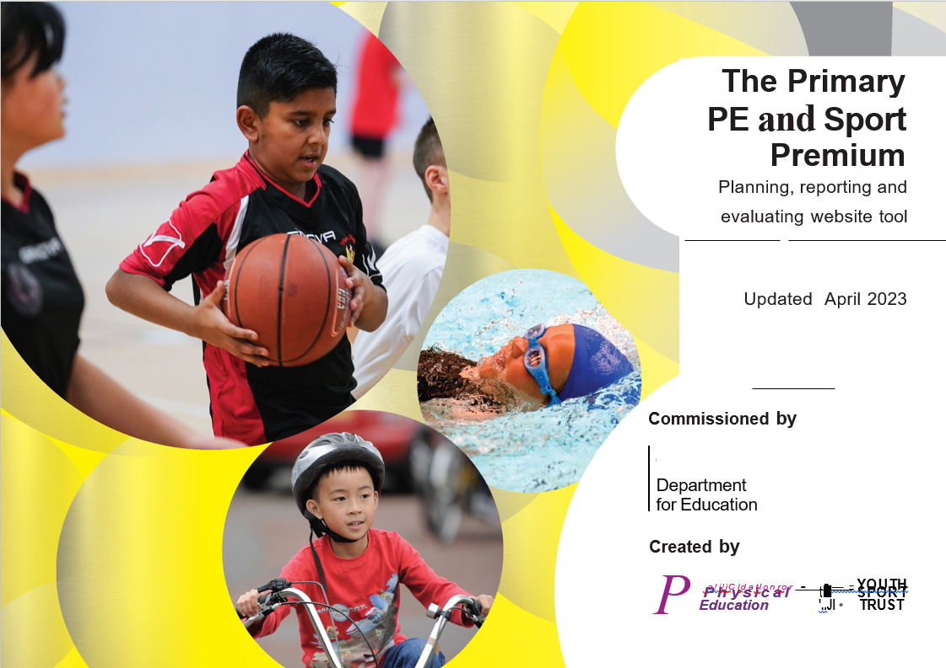

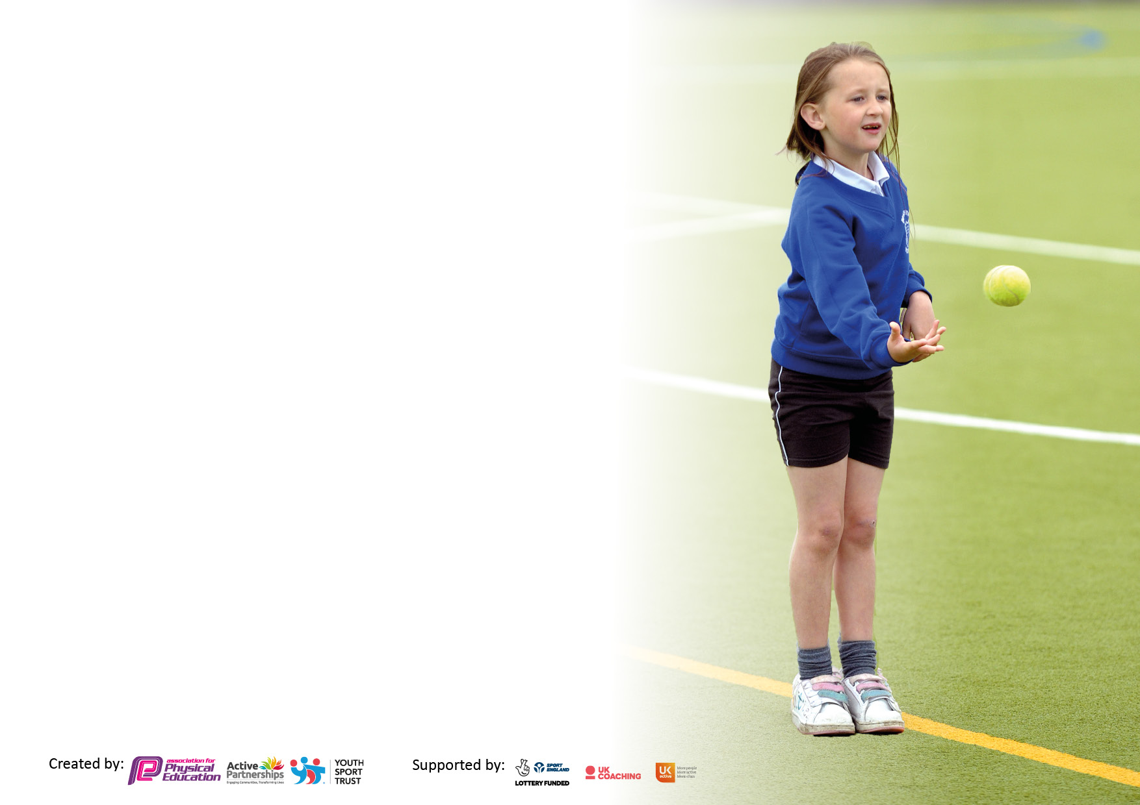

It is important that your grant is used effectively and based on school need. The Education Inspection Framework makes clear there will be a focus on **‘whether leaders and those responsible for governors all understand their respective roles and perform these in a way that enhances the effectiveness of the school’**.

Under the Quality of Education Ofsted inspectors consider:

**Intent** - Curriculum design, coverage and appropriateness

**Implementation** - Curriculum delivery, Teaching (pedagogy) and Assessment

**Impact** - Attainment and progress

To assist schools with common transferable language this template has been developed to utilise the same three headings which should make your plans easily transferable between working documents.

Schools must use the funding to make **additional and sustainable** improvements to the quality of Physical Education, School Sport and Physical Activity (PESSPA) they offer. This means that you should use the Primary PE and sport premium to:

* Develop or add to the PESSPA activities that your school already offer
* Build capacity and capability within the school to ensure that improvements made now will benefit pupils joining the school in future years
* The Primary PE and sport premium should not be used to fund capital spend projects; the school’s budget should fund these.

We recommend you start by reflecting on the impact of current provision and reviewing the previous spend.

Schools are required to publish details of how they spend this funding, including any under-spend from 2019/2020, as well as on the impact it has on pupils’ PE and sport participation and attainment. **All funding must be spent by 31st July 2024.**

We recommend regularly updating the table and publishing it on your website throughout the year. This evidences your ongoing self-evaluation of how you are using the funding to secure maximum, sustainable impact. Final copy must be posted on your website by the end of the academic year and no later than the 31st July 2024. To see an example of how to complete the table please click HERE.

Created by: Supported by:

**Details with regard to funding**

Please complete the table below.

|  |  |
| --- | --- |
| Total amount carried over from 2022/23 | £0 |
| Total amount allocated for 2023/24 | £19,000 |
| How much (if any) do you intend to carry over from this total fund into 2023/24? | £0 |
| Total amount allocated for 2023/24 | £19,000 |
| Total amount of funding for 2023/24. To be spent and reported on by 31st July 2024. | £19,000 |

**Swimming Data**

Please report on your Swimming Data below.

|  |  |
| --- | --- |
| Meeting national curriculum requirements for swimming and water safety.  N.B. Complete this section to your best ability. For example you might have practised safe self-rescue techniques on dry land which you can then transfer to the pool when school swimming restarts.  **Due to exceptional circumstances priority should be given to ensuring that pupils can perform safe self rescue even if they do not fully meet the first two requirements of the NC programme of study** |  |
| What percentage of your current Year 6 cohort swim competently, confidently and proficiently over a distance of at least 25 metres?  **N.B.** Even though your pupils may swim in another year please report on their attainment on leaving primary school at the end of the summer term 2023.  Please see note above | 72% of pupils |
| What percentage of your current Year 6 cohort use a range of strokes effectively [for example, front crawl, backstroke, and breaststroke]?  Please see note above | 48% of pupils |
| **What percentage of your current Year 6 cohort perform safe self-rescue in different water-based situations?** | 37% of pupils |
| Schools can choose to use the Primary PE and sport premium to provide additional provision for swimming, but this must be for activity **over and above** the national curriculum requirements. Have you used it in this way? | No |

**Action Plan and Budget Tracking**

Capture your intended annual spend against the 5 key indicators. Clarify the success criteria and evidence of impact that you intend to measure to evaluate for pupils today and for the future.

|  |  |  |  |  |
| --- | --- | --- | --- | --- |
| **Academic Year:** 2023/24 | **Total fund allocated:** | **Date Updated: July 2023** | |  |
| **Key indicator 1:** The engagement of all pupils in regular physical activity – Chief Medical Officers guidelines recommend that primary school pupils undertake at least 30 minutes of physical activity a day in school | | | | Percentage of total allocation: |
| 10.5% |
| **Intent** | **Implementation** | | **Impact** |  |
| Your school focus should be clear what you want the pupils to know and be able to do and about  what they need to learn and to  consolidate through practice: | Make sure your actions to achieve are linked to your intentions: | Funding allocated: | Evidence of impact: what do pupils now know and what can they now do? What has changed? | Sustainability and suggested next steps: |
| Children further develop skills to lead as Active Champions and take an active role towards consolidation of the targets achieved for the Gold Sports Mark.  Lunchtime and after school sporting clubs in place to support wellbeing and physical activity.  Children are encouraged to walk to and from school to support with increased physical activity of all pupils. | Successful applicants will be provided with training to support their role as Active Champions. Pupil interests and achievements outside of school will also be utilised to promote physical wellbeing.  An overview of additional sporting activities in place and allocated to children to support both physical and mental health.  Active champions will promote this within school with actions identified within half termly meetings. Once decided, actions will be promoted through newsletters, assemblies, competitions, and social media. | £2,000 | Children raised profile and skills in sport in all key stages during unstructured times and provided engagement in new sporting activities. Interests of achievements of children was utilised and showcased widely with the community. Peareswood Sport Lead Champions were promoted physical activities on our new digital platforms. Involvement in all contributed significantly with the school achieving the Gold Sports Mark.  Children contributed within the pupil voice committee developing their oracy skills and confidence when identifying next steps linked to their role. This was mirrored within their short videos providing knowledge of specific skills for the children in KS1 and KS2. Additional lunchtime clubs were put in place to enhance engagement in sport for identified children.  80% of our children walk to school each month. | To continue to develop the role of sport champions to develop this role of responsibility, provide leadership skills, support physical and mental health needs of all children. Further identification and utilisation of sporting achievements of individuals to support others. This could be digital spotlights to further promote.  To continue to promote walking to school, to support with national obesity levels in children and reduce overall pollution levels within the local area. Our Pupil Leadership Team can lead on this working in partnership with other pupil led groups. |
| **Key indicator 2:** The profile of PESSPA being raised across the school as a tool for whole school improvement | | | | Percentage of total allocation: |
| 10.5% |
| **Intent** | **Implementation** | | **Impact** |  |
| Your school focus should be clear what you want the pupils to know and be able to do and about  what they need to learn and to  consolidate through practice: | Make sure your actions to achieve are linked to your intentions: | Funding allocated: | Evidence of impact: what do pupils now know and what can they now do? What has changed? | Sustainability and suggested next steps: |
| To provide children with the skills  and opportunities to use a range of  sports skills in different contexts. | PE passport ensures lessons focus on skills which can be transferred across the curriculum. Children will also be able to apply skills within Local Authority, inter Trust and local school competitions. | £2,000 | Children have reinforced their skills in various sports activities, with lessons revisiting prior learning to ensure continuous skill development each year. AFL techniques are used to address any gaps in learning.  Additionally, 72% of children can now swim 25 meters, and an extra block of swimming lessons has been implemented to help fill any remaining gaps in their swimming abilities. | To continue to use this online sporting tool to ensure National Curriculum expectations are met and a range of skills fostered.  To continue to provide swimming opportunities for our children. |

|  |  |  |  |  |
| --- | --- | --- | --- | --- |
| **Key indicator 3:** Increased confidence, knowledge and skills of all staff in teaching PE and sport | | | | Percentage of total allocation: |
| 52.5% |
| **Intent** | **Implementation** | | **Impact** |  |
| Your school focus should be clear | Make sure your actions to | Funding | Evidence of impact: what do | Sustainability and suggested |
| what you want the pupils to know | achieve are linked to your | allocated: | pupils now know and what | next steps: |
| and be able to do and about | intentions: |  | can they now do? What has |  |
| what they need to learn and to |  |  | changed? |  |
| consolidate through practice: |  |  |  |  |
| Teachers are provided with CPL through the deployment of specialist teachers.  CPD opportunities are identified for school sport coaches to enhance current provision in school.  Medium- and short-term plans in place to support the sequence of teaching and skills within each area of the curriculum. | Teachers are provided with opportunities to observe outstanding practice and develop their practice. Application, for development, within whole school sporting events and after school clubs.  Working in collaboration with the local authority, sport coaches are provided with CPD which is then utilised within daily lessons.  Staff are provided with opportunities to review lesson sequences on PE passport and review based on the needs of the children and school context and identified need. | £10,000 | Sports coaches have undergone continuous professional development (CPD), leading to improved learning and outcomes for children.  Teachers have gained greater confidence in their knowledge and skills, understanding the significance of building upon prior knowledge to facilitate progress for every child.  Agreed plans are established, along with a structured sequence of learning that effectively meets the diverse needs of all learners. | CPD plays a vital role in the progress and academic outcomes of all pupils. Teachers new to role will also benefit from continued support in addition to ongoing CPD for Sport Coaches. |
| **Key indicator 4:** Broader experience of a range of sports and activities offered to all pupils | | | | Percentage of total allocation: |
| 10.5% |
| **Intent** | **Implementation** | | **Impact** |  |
| Your school focus should be clear | Make sure your actions to | Funding | Evidence of impact: what do | Sustainability and suggested |
| what you want the pupils to know | achieve are linked to your | allocated: | pupils now know and what | next steps: |
| and be able to do and about | intentions: |  | can they now do? What has |  |
| what they need to learn and to |  |  | changed? |  |
| consolidate through practice: |  |  |  |  |
| Pupils to access after school clubs to develop both physical and mental health.  Targeted groups in place to further develop the wellbeing of all children. | An overview of clubs for the year in place which provide a broad and balanced overview of the PE curriculum with opportunities for all year groups.  The school inclusion team and senior leaders, to identify individual children who would benefit from a sporting intervention to support with physical, mental health and self-esteem need of children. | £2,000 | Children were provided with sporting opportunities throughout the year in addition to competing in Bexley Football tournaments and multi-Sport competitions.  All clubs were well attended, which included training sessions for tournaments.  A reduction in SEMH needs, engagement in learning and raised self-esteem was evidenced within groups of children. | This provision will continue next year to further develop skills and provide opportunities for all.  This provision will remain to support our most vulnerable children. |

|  |  |  |  |  |
| --- | --- | --- | --- | --- |
| **Key indicator 5:** Increased participation in competitive sport | | | | Percentage of total allocation: |
| 16% |
| **Intent** | **Implementation** | | **Impact** |  |
| Your school focus should be clear | Make sure your actions to | Funding |  |  |
| what you want the pupils to know | achieve are linked to your | allocated: |  |  |
| and be able to do and about | intentions: |  |  |  |
| what they need to learn and to |  |  |  |  |
| consolidate through practice: |  |  |  |  |
| Children are provided with competitive opportunities. | Opportunities for competitive sports are identified and children are provided with additional coaching to support with this.  Interests of children identified and developed through applications to join different sporting leagues.  School based equipment is relevant and further enhance development of children. | £3000 | The school was registered to a football league this year for boys and girls. In addition, the children took part in other competitive events, cricket, multi-sports, and netball. This fostered confidence and provided a platform to practice skills from lessons. | This will continue again next year to further improve skills and provide high aspirations for all children. |

|  |  |
| --- | --- |
| Signed off by | |
| Head Teacher: | Carla Ferla |
| Date: | 7th July 2023 |
| Subject Leader: | Sarah Jackson |
| Date: | 6th July 2023 |
| Governor: | Iona Wallace |
| Date: | 7th July 2023 |